Access – Problem 2

- Access Flow

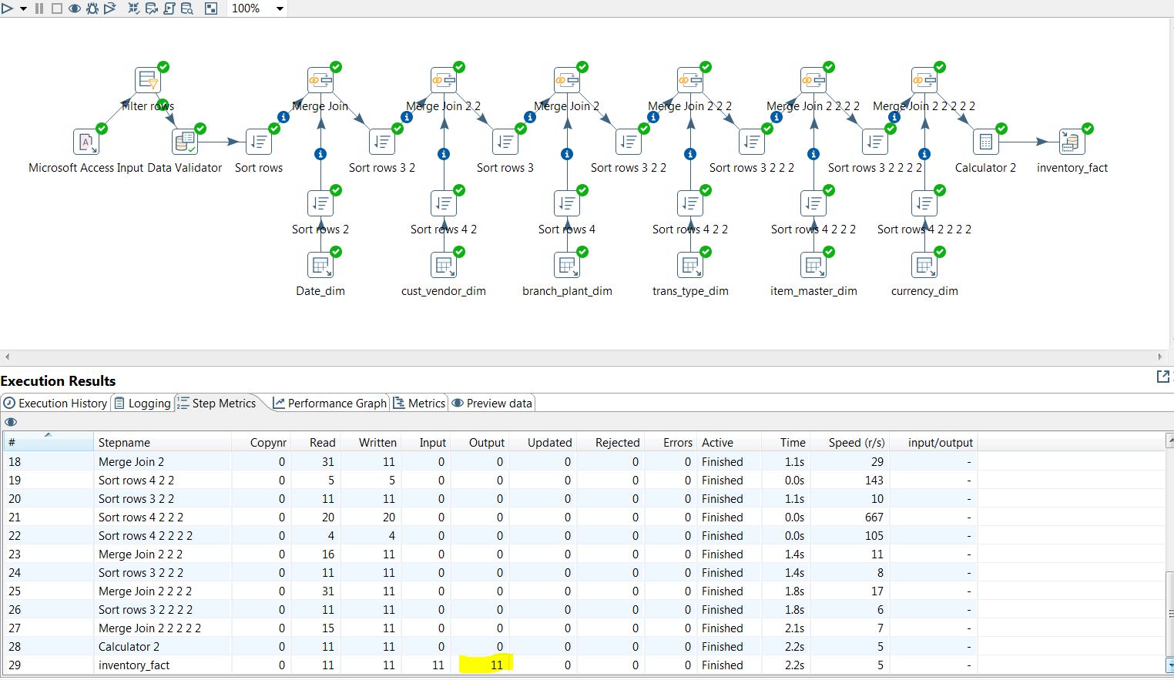

- Execution Flow result

- Insert / Update

